**HTTP status codes homework**

**Step #1** - Open Google Chrome with DevTools

**Step #2** - Open link: <https://www.makeup.com.ua/ua/>

**Step #3 -** Result - we sent a GET request and received status code 301 which means “Redirect”. This means that our website is located on another URL and we are automatically redirected to the correct link: <https://makeup.com.ua/ua/>

[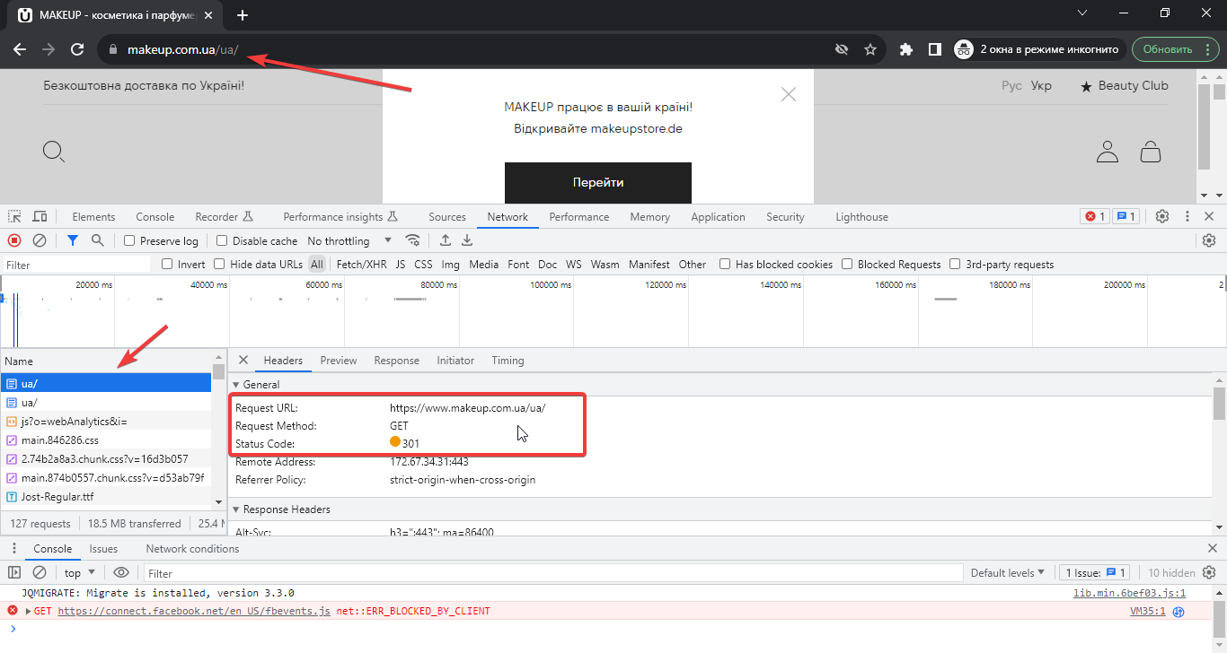](https://i.imgur.com/6qopx1U.png)

**Step #4** - Open link: <https://makeup.com.ua/>

Result - we sent a GET request and received status code 200, which means that request was handled correctly and all is ok.

[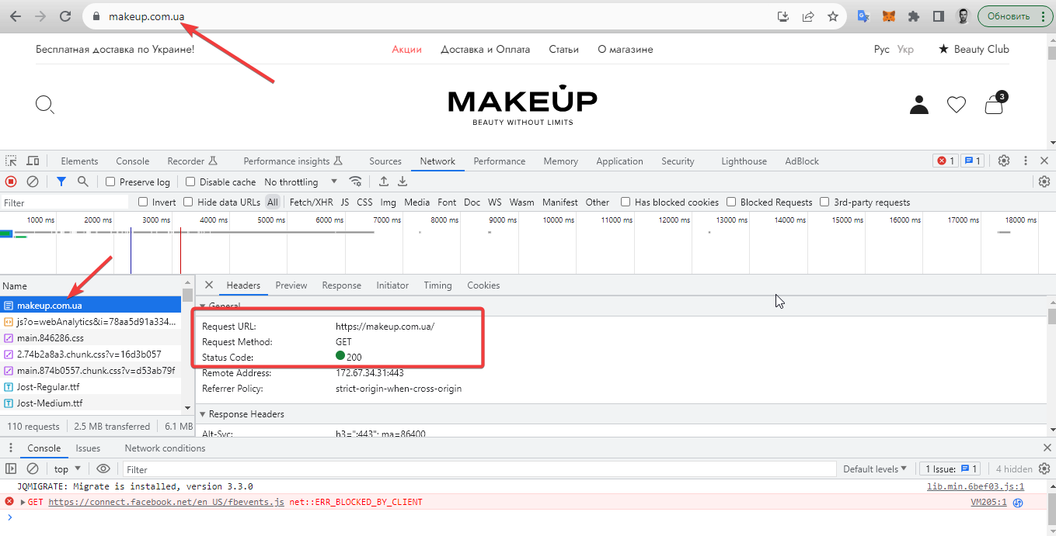](https://i.imgur.com/nlpHcOS.png)

**Step #5** - Add product to cart

Result - we sent a PUT request (this means we are rewriting an instance or record) and received status code 200, which means that request was handled correctly and we have updated our cart by adding a product.

[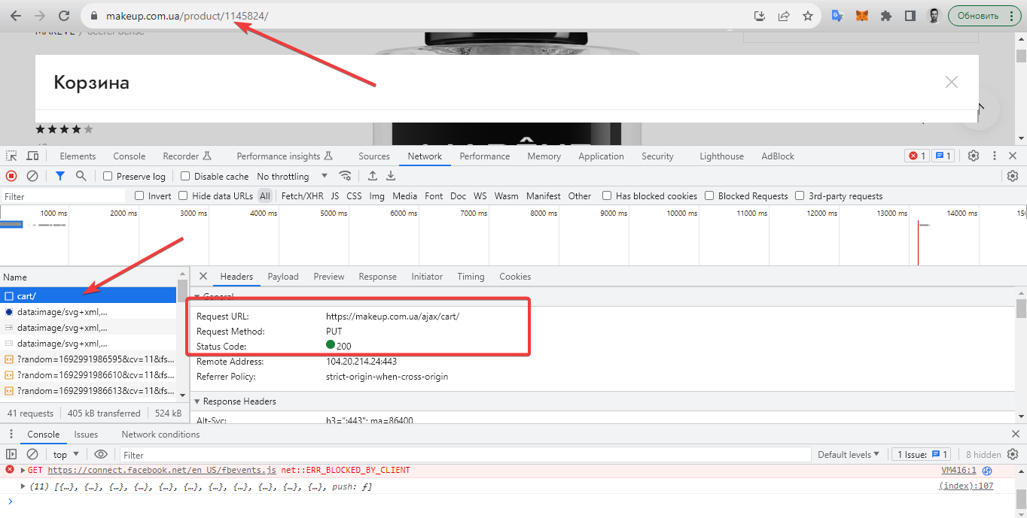](https://i.imgur.com/WjuwXoD.png)

**Step #6** - Open link: <https://www.makeup.ua/>

Result - we sent a GET request and received error with status code 526 (backend or server error), means that SSL certificate presented by the server did not pass validation.

[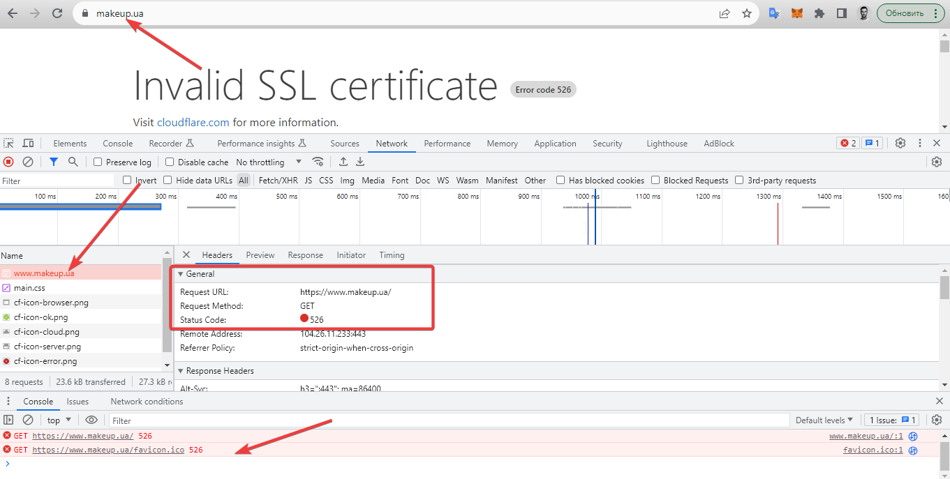](https://i.imgur.com/K1DsMgi.png)